Hi David!

This is the brief summary of what I have done. There are two main things:

1. Using VNIR data to predict the amount of bastnaesite.
2. Unmix different REE- bearing mineral spectrum in ‘DT’s custom REE- mineral library’, using multiple Gaussian modeling.

And the brief- illustrated results are:

1. The largest R squared of estimation is about 0.923 (small absorption used in big absorption area, like 6 absorptions have been considered in 700nm- 775nm)

Here comes details of the algorithm I used and why I used them.

1. REE-mineral amount estimation.

The workflow process is:

1. Loop the whole picture (totally, there are 6 rock samples) and get the spectrum from pixel.
2. Smooth the spectrum, because there are too many noises that would impact the following result.  
   And these are smooth results.

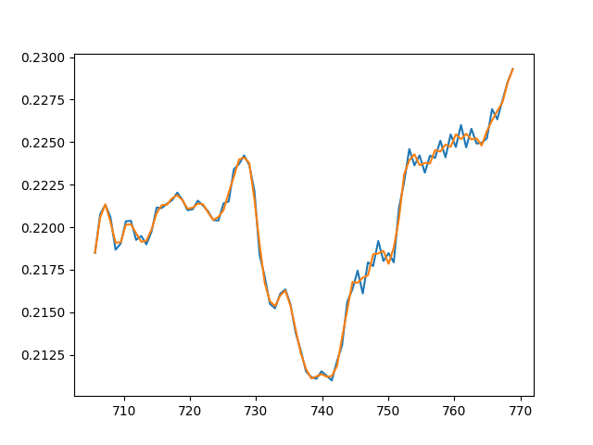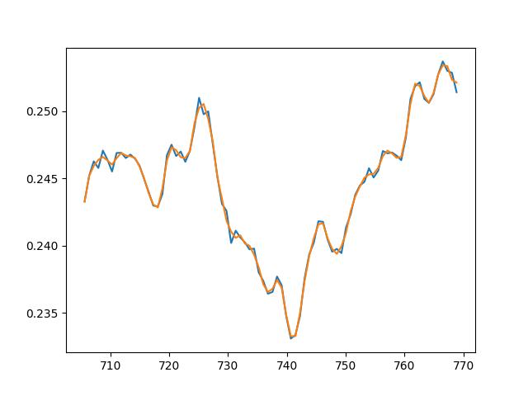

1. Possibility Checking

This procedure is to differentiate spectrums which is possible to be ‘bastnaesite’ and which is not (Lower one is possible, upper one is not.)

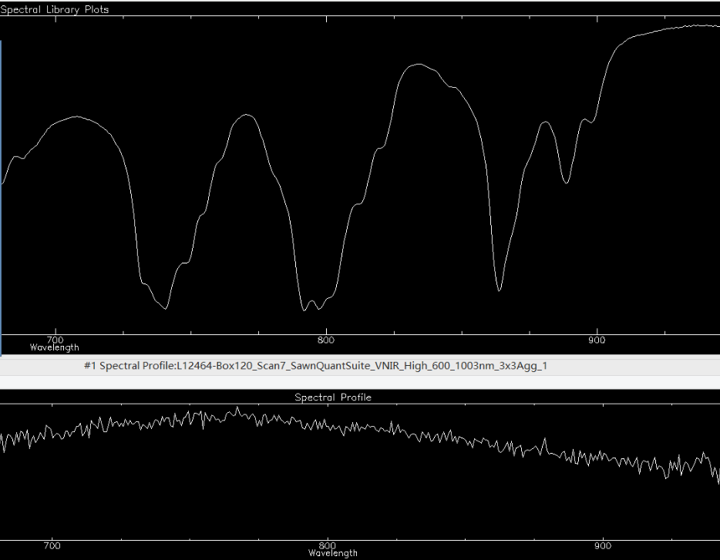

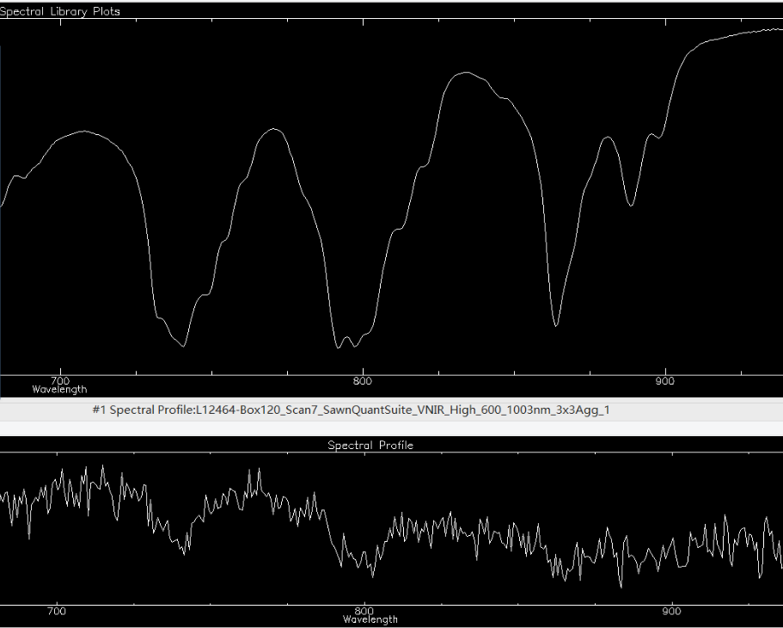

The method I use to achieve this target is:

1. Check the depth of big absorption area, like 700-775nm, depth is ‘reflectance ’

